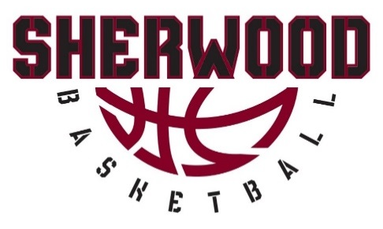

2022-2023 SCHOLARSHIP ASSISTANCE PROGRAM
APPLICATION FORM

The Sherwood Basketball Organization (SB)) works to provide financial assistance to families in need. The SBO Scholarship Assistance Program focuses on providing opportunities for our area youth to participate in basketball for the physical, mental and character-training benefits that this organization can provide. Full and partial scholarship assistance will be dependent upon SBO funds available and the actual need shown.

Requirements for eligibility:
- Commitment to adhere to your coach/team participation rules.
- Participation by a family member to volunteer at all SBO opportunities during the scholarship season.
- Application must be completed by a parent, guardian, or head of household, with all requested information provided.
- Incomplete applications will not be considered.
If your family receives assistance from programs such as SNAP, Medicaid, SSI, Foster Care, WIC, etc., please provide written documentation to receive priority status.

Approval process of a registration scholarship does not register the participant for SBO. You will still need to complete all registration documents as well.

The SBO Scholarship Committee will review your application and determine if you qualify for an award. Please make sure all information is complete and correct. Any personal information that you are required to provide will be kept confidential within the SBO Scholarship Committee. We aim to inform scholarship applicants of our decision by the following week of the tryout your player attends.

Submit a completed and signed form to registrar@sherwoodbasketball.com.

DUE DATES:
Girls Classic: October 7, 2022
Boys Classic: October 14, 2022
Youth Rec: October 29, 2022
High School Rec: December 3, 2022

NOTE: INCOMPLETE APPLICATIONS WILL NOT BE CONSIDERED

Date of Application: ____ _________ Submitter’s Name: ___________________________
Player’s Full Name: _____ Phone Number: __________
Address: ________________
City: ______ __ State: ________ _ Zip Code:
Which program is your player registered in?
Girls Classic ___ Boys Classic ___ Youth Rec ___ High School Rec ___
Household Size: ______ How many players are you registering for SBO? _____________________
What is the maximum amount you can pay towards the registration fee? _______________
If applicable, please list any assistance programs your family qualifies for: _____________________
____________
Please explain your request/circumstances:
____________
____________
____________
CONSENT TO RELEASE INFORMATION
I understand that my signature authorizes SBO to obtain verification of all the information on this application. I certify that all of the information on this form is true and correct. I understand that my child(ren)’s participation in this program requires a commitment to adhere to the coach/team participation rules. I agree to notify SBO of any change in my income or ability to pay. I am aware that assistance funds are awarded for a maximum of one year, after which time it is my responsibility to reapply.
Parent/Guardian’s Name (print): _____________ _______
Parent/Guardian’s Signature: Employer:
Parent/Guardian’s Name (print): _____________ _______
Parent/Guardian’s Signature: Employer:

